“Golden Welt” von Georg Britting
Aus: Die Goldene Welt (München, 1996)

Im September ist alles aus Gold:
Die Sonne, die durch das Blau hinrollt,
Das Stoppelfeld,
Die Sonnenblume, schläfrig am Zaun,
Das Kreuz auf der Kirche,
Der Apfel am Baum.
Ob er hält? Ob er fällt?
Da wirf ihn geschwind
Der Wind
In die goldene Welt.
Comprehension
This poem describes the feelings of warmth, relaxation and the sense of fulfilment at the end of summer. Life seems trouble-free – the ferocious heat of summer has gone and the cooler days of autumn have not quite arrived. The harvest time is nearing and fruits from trees seem to literally fall into our hands like in paradise. The world appears golden – a metaphor for prosperity and for warmth, comfort and health. Nature is personified in this poem as relishing this time – the sun is “rolling” in the blue sky and the wind toys with fruit in the trees. The sunflower is dreamily basking in the warm rays of the sun – just in the same way we may cherish the last warm, carefree days of summer. Interestingly, the author mentions only one man-made object – the cross on the church roof. In contrast to all the other natural details this cross is actually made of gold. This mention of the cross may herald the burden of the long winter which awaits us.
Glossary
das Stoppelfeld | Stubble field
schläfrig | Sleepy
geschwind | Quick, swift, fast
die Sonne, die durch das Blau hinrollt | Rising and falling sun in the sky

Suggested activities
- Give these word cards to learners and ask them to find out what the words have in common: GOLD, STOPPELFELD, WIND, APFELBAUM, GOLDENE WELT, SONNENBLUME

Alternatively, you may create a mind-map and collect ideas that the pupils associate with “Herbst”. Pupils may add words such as: der Wind, die Blatter, kalt, der Regen, die Wolken, dunkel, nass, weiss…
- Read the poem aloud and ask learners to do the same. Let them decide who they think is asking the two questions in line 7 of the poem. The narrator of the poem seems to be an observer who watches the wind and the apples falling. Find out from the class if they have ever sat and observed nature this closely. Ask them to highlight all the words that can be referred to as “golden” in the poem (die Sonne, das Stoppelfeld, die Sonnenblume, das Kreuz, der apfel…)
- These activities will introduce the concept of rhyming in German. Ask learners to make pairs of words that rhyme from the following:
Zaun | Wind | hält
Welt | Baum | hinrollt
Gold | fällt | geschwind
Cut the lines of the poem apart, shuffle them and ask the class to put them into the correct order or – to be more creative – into any other meaningful order of their choice using the rhyming words at the end of each line.
- Pupils could use this poem as an inspiration to write their own short form poems, e.g. ciquains or diamante poems. See appendices.

Cinquain Graphic Organizer

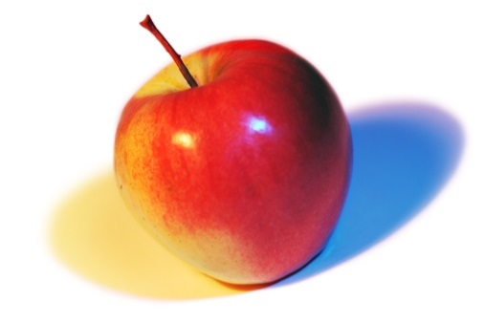
A cinquain is a five-line poem that describes a person, place, or thing.

Apple
Red, Shiny
Biting, Chewing, Bobbing
Do Not Eat the Seeds
Snack!

Use this organizer to write your own cinquain.
One word that tells what your poem is about (its subject)

Two words that describe your subject
Three doing words associated with your subject.

A sentence or phrase that tells us something else about your subject.
One or two words that rename your poem (a synonym for your subject).

Diamante poems
- Diamante poems are seven lines long.

- The first and last lines have just one word.
The second and sixth lines have two words.
The third and fifth lines have three words.
And the fourth line has four words.
Noun
Adjective, Adjective
Verb, Verb, Verb
Noun, Noun, Noun, Noun
Verb, Verb, Verb
Adjective, Adjective
Noun

This gives the poem its unique diamond shape.

- Suggested forms:
Lines 1, 4, and 7 contain nouns only
Lines 2 and 6 contain adjectives only
Lines 3 and 5 contain verbs only
You can, of course, make up your own rules when making a diamante poem. It could be made up entirely of nouns, or nouns and adjectives, or verbs and nouns, or adverbs and nouns, or adjectives only… the list goes on!

SYNONYM DIAMANTE
In these diamantes, the words “Monsters” and “Creatures” mean the same thing, so they are synonyms as are “Education” and “School”.
Monsters
Evil, Spooky
Howling, Shrieking, Wailing
Ghosts, Vampires, Goblins, Witches
Flying, Scaring, Terrifying
Creepy, Crawly
Creatures

Education,
Useful, powerful
Reading, writing, learning
Books, sports, instruments, experiments
Talking, listening, growing
New, interesting
school

ANTONYM DIAMANTE
In these diamantes, you might say that the words “Cat” and “Dog”, and “Summer” and “Winter” are opposites, or “antonyms”, so this is an antonym diamante. Lines 2 and 3 refer to line 1. Lines 5 and 6 refer to line 7. Line 4 refers to both lines 1 and 2.

Cat
Gentle, Sleepy
Purring, Meowing, Scratching
Whiskers, Fur, Collar, Leash
Barking, Licking, Digging
Slobbery, Playful
Dog

Summer
Golden, warm
Glowing, shimmering, soothing
Green, white, yellow, blue
Tightening, closing, darkening
Icy, still
Winter

Use this template to make your own diamante.

